Question 1:

The time till failure of an electronic component has an **Exponential distribution** and it is known that 10% of components have failed by 1000 hours.(Say X is the random variable representing time till failure of electronic components) (a)Find **λ** in the formula of exponential distribution PDF (b) What is the probability that a component is still working after 3000 hours? (c) Find the standard deviation of X

Answer 2:

1. Let X = time till failure of electronic components. Since 10% of them failed before 1000 hours, P(X <= 1000) = 0.1 = 1-e-1000λ => λ = 1.054ⅹ10-4
2. P(X >= 3000) =1-( 1- e-3000λ) = 0.729
3. Variance is $\frac{1}{λ^{2}}$ = 90015806.7. So σ = $\sqrt{\frac{1}{λ^{2}}}$ = 9487.67.

Question 2:

A defective coin whose probability if getting head is random variable X with PDF

FX(x) = $\left\{\begin{aligned}xe^{x}, x∈[0,1] \\ 0, otherwise\end{aligned}\right.$

This coin is selected and tossed repeatedly, with each tosses are independent.

Try to find the probability that this coin toss results in head.

Answer 2:

Continuous of total probability theorem:

**P**(A) =

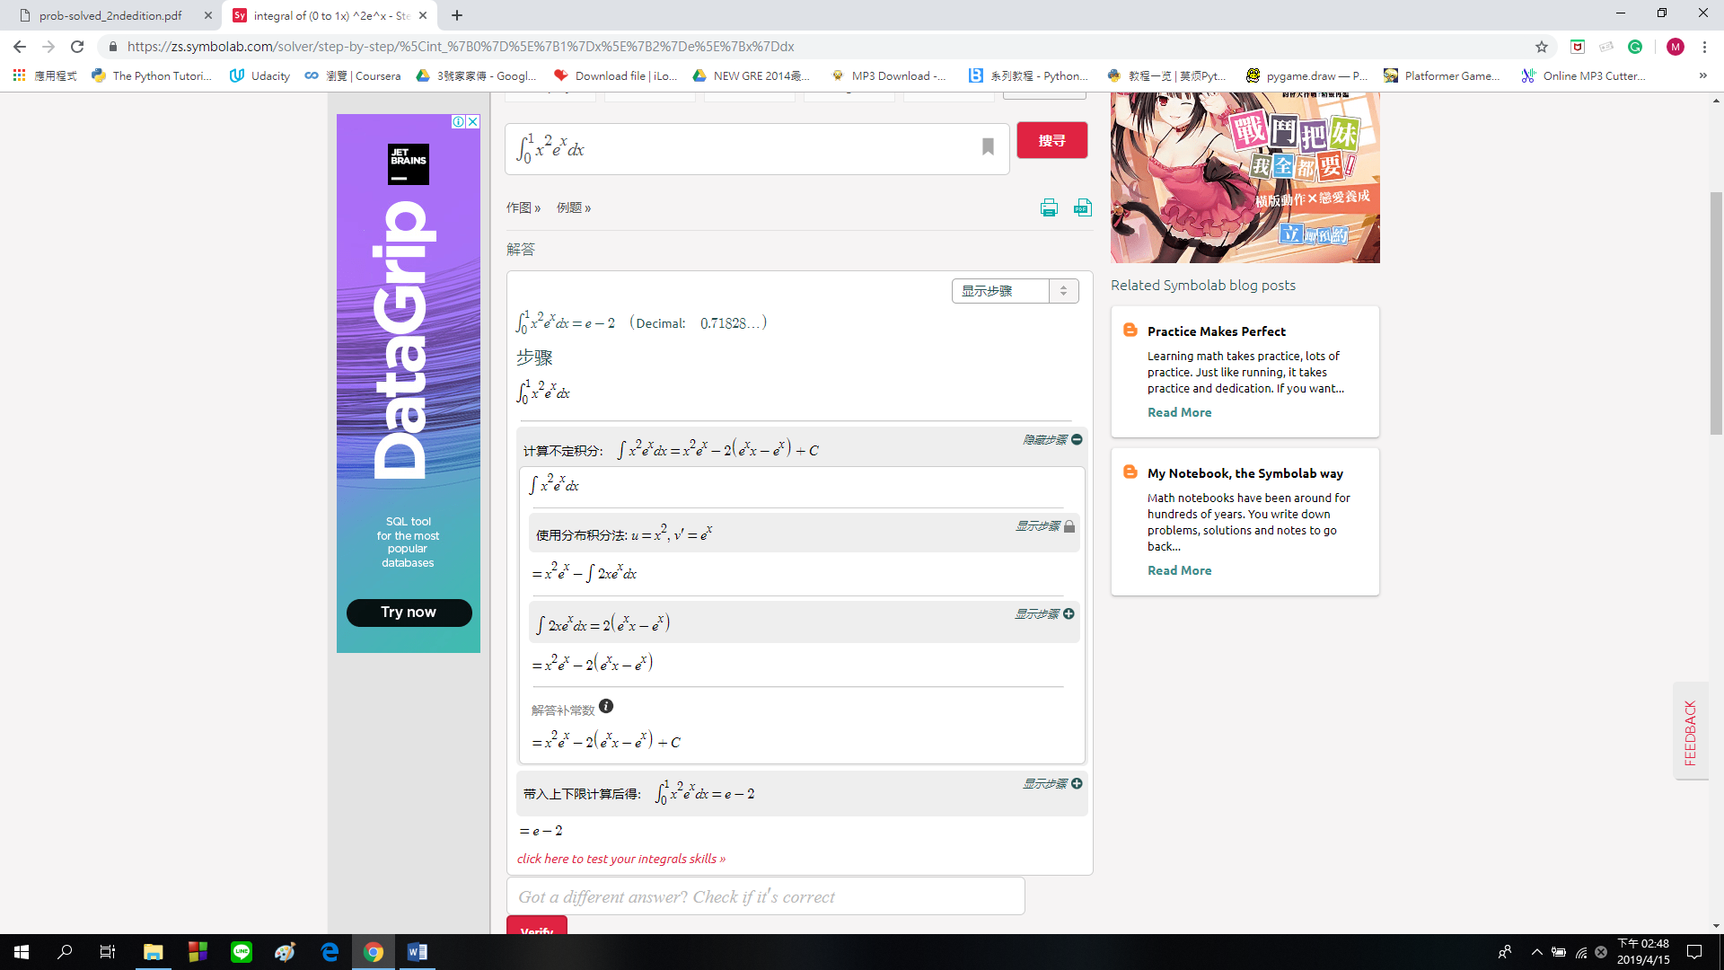



Question 3:

The taxi stand and the bus stop near Uncle Lee’s dormitory are in the same location.Uncle Lee goes there at a given time and if a taxi is waiting(this happens with probability 3/4 )he boards it.Otherwise he waits for a taxi or a bus to come,whichever comes first.The next taxi will arrive in a time that uniformly distributed between 0 and 20 minutes, while the next bus will arrive in exactly 8 minutes. Find the CDF and the expected value of Uncle Lee’s waiting time.

Answer 3:

Let A be the event that Uncle Lee’s will find a taxi or will be picked up by the bus after 8 minutes.

P(a taxi will take more than 8 minutes to arrive)= $\frac{3}{5}$

Uncle Lee’s waiting time, call it X,is a mixed random variable ,with probability

P(A)= $\frac{3}{4}+\frac{1}{4}*\frac{3}{5}=\frac{9}{10}$

it is equal to its discrete component Y

PY(y)= $\frac{3}{4P\left(A\right)}=\frac{30}{36} ,if y=0$

= $\frac{3}{20P\left(A\right)}=\frac{6}{36} ,if y=8$

With the complementary probability 1-P(A),the waiting time is equal to its continuous component Z,which has PDF

fz(z)= $\frac{1}{ 8 }, if 0≤z≤8$

=0, otherwise

The CDF is given by Fx(x)=P(A)Fy(x)+(1-P(A))F

Fx(X)=0, if x<0

= $\frac{3}{4}+\frac{1}{10}*\frac{x}{8}$, $if 0≤z<8$

=1, if 8 $≤$ x

E[X]= $\frac{9}{10}*\frac{1}{6}*8+\frac{1}{10}*\frac{8}{2}=\frac{8}{5}$

Question 4:

A company produces basketball,and the diameter of basketball X is a Laplacian random variable with probability density function

 ,where 。A guess need a basketball which diameter is between the interval [4.00-0.016,4.00+0.016].The guess cannot accept diameter excess this range.Find the percentage the basketball the guess can accept of all basketballs?

Answer 4:



Question 5:

Let the joint probability density function of continuous random variables X and Y be given by

f(x, y) = $\left\{\begin{aligned}2 if 0 < x < y < 1 \\ 0 otherwise\end{aligned}\right.$

Find $f_{X|Y}$ (x|y).

